|  |
| --- |
| JAVA PROJECT DESCRIPTION |
| PROJECT NAME: INTERNET SERVICE PROVIDER |
| **NAME: Ange ISHIMWE NGIRABAKUNZI REG NO:221022976 CLASS NO:03** |

**1.PLANNING**

Internet Service Provider Project (ISP) which is used for administration of ISP company every’s day activities like: giving internet and management employee data in the system and also manage customers , create plans and complaints Managements.

**goals**

1. The admin of ISP companies got what they needed, or what they wanted.
2. The admin of ISP companies was able to easily make use of this project.
3. The quality, performance, security of the project were acceptable to the admin.
4. To utilize a reasonable amount of resources in building it.
5. To complete the work in a reasonable amount of time.
6. The work was built to be maintained or updated or expanded.

In Future this system need to facilitate the better administration of internet service providers company also to manage customers well, and also employee.

This project can also be used in Rwandan ISP companies like MTN to manage customer’s complaint.

**2.DESIGN**

This system will work as desktop application for administration of internet service provider companies so it was developed using netbeans with java swings and connected with mysql database for well functionality.

Admin to use this system need to login first for authentication and if credentials are correct he/she(admin) will be able to see his/her dashboard which is composed by navigations like

* Create plan
* Manage customers
* Manage complains
* Manage employee
* Logout

When inside those navigations you will find ways to manage by adding information ,delete buttons ,update buttons .

And some icons which backs to admin page .

This system is designed to be used by only one user that is admin.

Let’s discuss how this user will use this system:

He/she will login first and after login home page will allow him/her to create plan in case he/she found market for the internet, after creating plan he/she is also able to edit/delete the plan as long as it is no longer in plan. Here is also an option of recording ,viewing ,updating and deleting a customer for management, in complain management admin will have to tick or untick according to solving of complains ,so when any complain is solved he/she will thick.

This system is designed in the way that we have **to search by contact and update name in any table**

**Designer’s eye:**

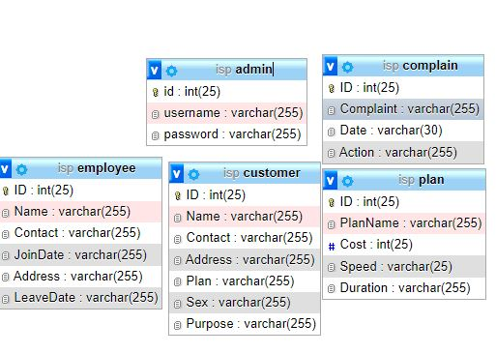

**Designer’s usecase diagram to show how admin will carry different activities**

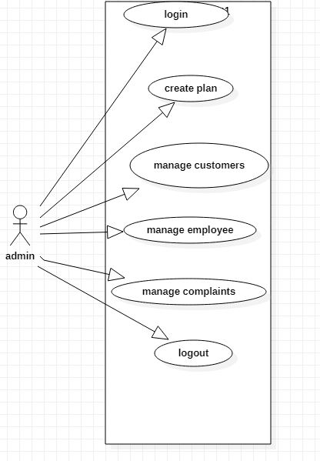

**FUNCTIONAL REQUIREMENTS**

are requirements that support tasks, activities ,user goals for easier project management.

Here there are list of functional requirements to be included in ISP project:

* **Authentication functions:** this requirement will help us to validate admin’s credentials before doing any other activity on system.
* **System requirement:**  involve specifications for software and hardware such as computer ,database and more. these include the specific action that system takes to complete the task.
* **Administrative protocol:** to help us perform special operations include system reporting and testing to ensure the system runs properly.
* **external interfaces:** these are user preferences which help individual operate system easily.it may involve specific features like the interfaces ,navigations.

**TECHNICAL REQUIREMENTS**

Are those requirements which help system to work efficiently,and user may have no idea on what’s going on with that functions.

Here there are list of technical requirements to be included in ISP project:

* **usability:**  by making sure that our system is easy to use and navigate with no complexity.
* **Reliability:** this makes system available in want and no data loss.
* **Maintainability:** to add new features to our system.
* **Security:** by inclusion of protocol like on user accessibility of data in database to ensure data stored remains safe.

**3.DEVELOPMENTS**

**Technology Used :**

1. Front end : Java Swing.
2. Database :Mysql Database
3. IDE Used : Netbeans 8.2
4. Connector: msql connector

After planning and design we created database called **“isp”** to store the information in tables that are:

* Admin
* Customer
* Complains
* Plan
* Employee

And made relationships among them by using primary keys and foreign keys and after database we had to connect with our system files coded in netbeans software and its swings for graphical design and to connect we used mysql connector.

**4.TESTING**

In testing phase of system development we imported our project in many different operating system and we found that It can run in either windows or macs, the issue we met is that it is hard to import netbeans project to other platforms like eclipse.

**5.DEPLOYMENT**

To distribute our project we had to take computers which have netbeans installed, wamp server for database, and connector in that way our system can be imported and accessed.